PDCA Cycles Record
Problem or Challenge:
Target or Goal:
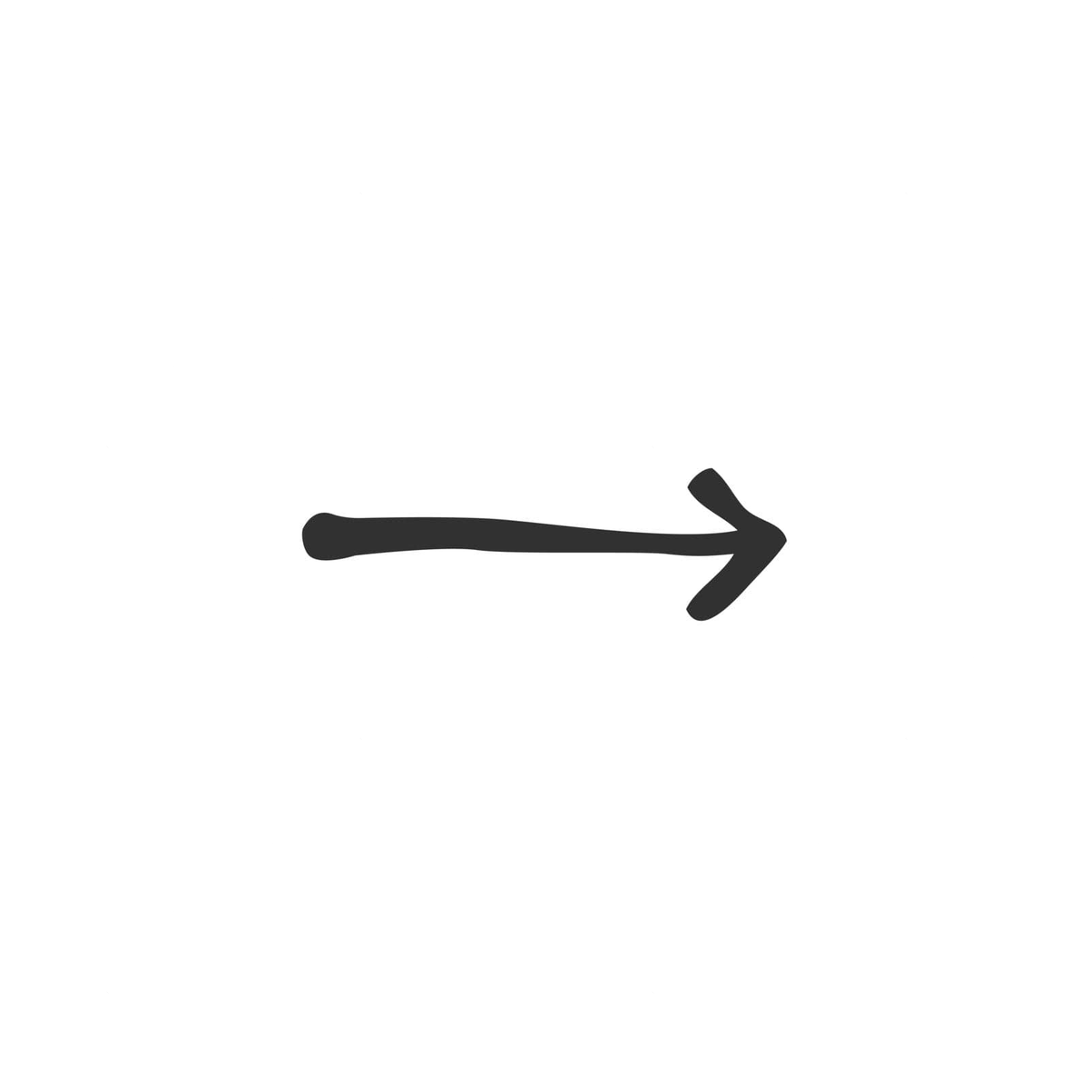
By When:
PLAN
Do
Check
Adjust

 | What will you try? | What do you expect? | Run the Experiment | What happened? | What did you learn? What will you try next?
Experiment 1 |  |  | Run the Experiment
Experiment 2 |  |  | Run the Experiment
Experiment 3 |  |  | Run the Experiment
Experiment 4 |  |  | Run the Experiment
Experiment 5 |  |  | Run the Experiment
Tips: Be specific and explicit with each step. Who, what, where, when, how? For how long? Use data when possible. Share your findings.

